**Written by** [**bbaktech@gmail.com**](mailto:bbaktech@gmail.com) **, contact for doubts**

**SIMULATIONUSING iFogSim2: Case Study — A Latency-sensitive Online Game**

In EEG Tractor Beam game, each player needs to wear a MINDO-4S wireless EEG headset that is connected to his smartphone. The game runs as an Android application on a user’s smartphone. The application performs real-time processing of the EEG signals sensed by the EEG headset and calculates the brain state of the user. On the application’s display, the game shows all the players on a ring surrounding a target object. Each player can exert an attractive force onto the target in proportion to his level of concentration (estimated using a ratio of the average power spectral density in the EEG α, β and θ bands of the player).

In order to win the game, a player should try to pull the target toward himself by exercising concentration while depriving other players of their chances to grab the target. Real-time processing requires that the application be hosted very close to the source of data - preferably on the smartphone itself. However, such a deployment would not allow global coverage - which typically requires deploying the application in the cloud. Such a mix of conflicting objectives makes this application a typical use-case for Fog computing.

**Application model**: As illustrated in Figure, the application EEG Tractor Beam Game consists of three major modules which perform processing -

1. **Client**: Client module interfaces with the sensor and receives raw EEG signals. It checks the received signal values for any discrepancy and discards any seemingly inconsistent reading. If the sensed signal value is consistent, it sends the value to the Concentration Calculator module to get the concentration level of the user from the signal. On receiving the concentration level, it displays it by sending the value to the actuator DISPLAY.

2. **Concentration Calculator**: The concentration calculator module is responsible for determining the brain-state of the user from the sensed EEG signal values and calculating the concentration level. This module informs the Client module about the measured concentration level so that the game state of the player on the display can be updated.

3. **Coordinator**: Coordinator works at the global level and coordinates the game between multiple players that may be present at geographically distributed locations. The Coordinator continuously sends the current state of the game to the Client module of all connected users.

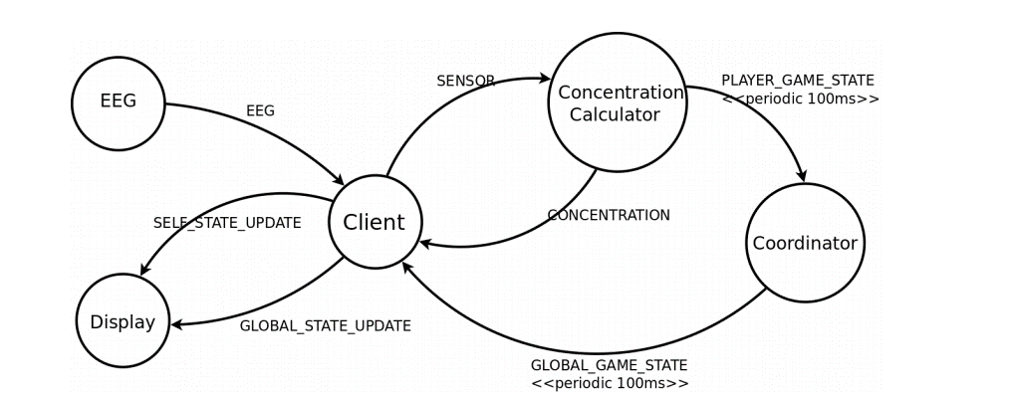

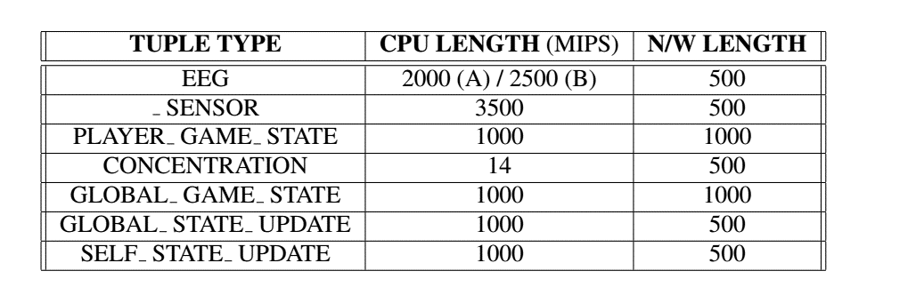

The application modules are modelled in iFogSim using AppModule class. As depicted in above Figure there are data dependencies between modules, these dependences are modelled using AppEdge class in iFogSim. Finally, the control loop of interest for EEG application is modelled in iFogsim using AppLoop class. The application is fed EEG signals by a sensor EEG and an actuator DISPLAY displays the current game-scene to the user.

**Physical Network For the case study**, we have considered a physical topology with 4 Fog devices. Table illustrates the configurations of the different types of Fog devices used in the topology , EEG headsets have been used —emitting tuples shown in below Table.

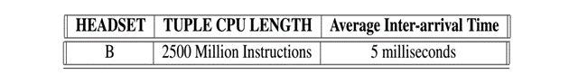

The physical topology of the case study is modelled in iFogSim via FogDevice, Sensor, and Actuator classes.

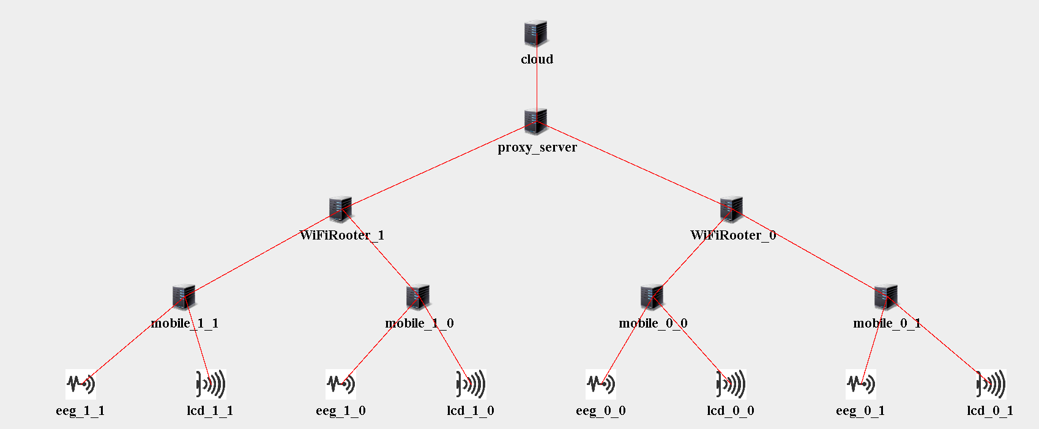

Each headset is connected to a smartphone via Bluetooth communication link. Smartphones gain access to the Internet through WiFi gateways that are connected to the ISP Gateway. For the purpose of testing iFogSim’s performance on varying topology sizes, we have varied the number of WiFi gateways keeping the number of smartphones connected to each gateway constant.

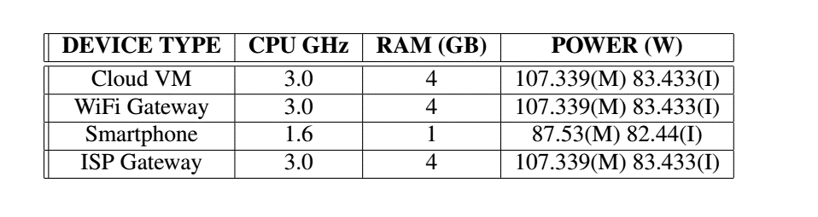

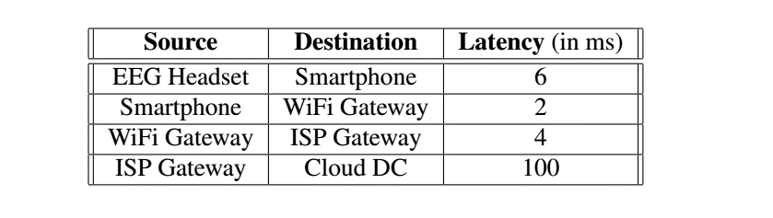

Sourse code: EE_GameFog.java

Pls contact : [bbaktech@gmail.com](mailto:bbaktech@gmail.com) for any doubts.